

COMPUTER USER'S GUIDE
FOR TENNESSEE D.O.T., SURVEY OFFICE

This manual contains documentation for most computer processes used by the Survey Office of the Design Division to accomplish day to day surveying tasks. The majority of the manual deals with CADD issues, and the Geopak™ program in particular. Other computer questions and processes are covered. Field processes as relates to electronic data collection are also covered. All processes are specific to equipment and software used by T.D.O.T.
This manual is intended as information and instruction to accomplish a finished survey. This document in no way relieves the surveyor from any requirements contained in the Survey Manual or the survey contract.
This document may be freely copied and distributed as needed. However, the author offers no warranty and accepts no liability for any omissions or errors contained herein.
Direct any questions or comments to above address.

To print the updated pages, load this document into Word. Then on the menu select FILE | PRINT. Pick the radio button to print only certain pages and type the page ranges exactly as listed below including all commas and dashes. Then, pick OK.

Most Recent Modified Page Nos.:
06/01/2000 – first release

PART 1 – FIELD OPERATIONS 4
ABOUT POINT DESCRIPTORS 4
USE OF FIELD BOOKS 5
RUNNING LEVELS WITH THE ZEISS DIGITAL LEVEL 5
FIELD ITEMS TO TAKE ADVANTAGE OF LEAST SQUARES 6
PART 2 – OFFICE OPERATIONS 7
OFFICE WORKFLOW 7
ABOUT FILENAMES 7
TRAINING VIDEOS 8
CREATE A NEW JOB ON THE COMPUTER 9
RETREIVING CONTROL POINTS FROM THE GPS DATABASE 13
INPUTTING KNOWN GPS CONTROL 15
DUMPING AND PROCESSING FIELD DATA 17
ADDING CONTROL FROM A PREVIOUS RUN TO CTL FILE 21
RAW DATA EDITOR 23
INTERPRETING LEAST SQUARES ADJUSTMENT REPORTS 25
IMPORTING AERIAL MAPPING FILES TO GEOPAK 30
DUMPING ZEISS DIGITAL LEVEL AND ADJUSTING LEVEL NOTES 30
CHECKING AND CORRECTING BREAKLINES 28
DIGITAL TERRAIN MODELS 32
THREE PORT VIEWER 37
CREATING ALIGNMENTS 37
PROFILES 37
SIDEROAD PROFILES 37
STAKEOUT 37
R.O.W., PROPERTY, AND AREAS 37
CREATING ACQUISITION TABLES 37
GENERAL INFORMATION ABOUT PLOTTING 38
PLAN SHEETS 38
LEVEL STRUCTURE 38
REFERENCE DIAGRAMS 45
PLACING SYMBOLS and TEXT 45
PLACING PIPES ON PROFILES 45
PLACING CULVERTS ON PROFILES 45
PLACING OH WIRES ON PROFILES 45
PLACING BENCHMARKS ON PROFILES 45
lABELING CATCH BASINS AND MANHOLES plAN AND PROFILE 45
DRAINAGE MAPS 45
DRAINAGE INFO 47
BRIDGE SURVEYS 47
PROCEDURE FOR ADDITIONAL INFORMATION 47
FILLING OUT WEEKLY REPORTS 47
WORKING WITH ZIP FILES 50
CORRESPONDANCE 51
APPENDICES 53
APPENDIX A - POINT DESCRIPTORS 53
APPENDIX B - COMPUTER FILENAME CODES 55
APPENDIX C – TDOT CUSTOM LINESTYLES 56
APPENDIX D - TURN-IN ITEMS CHECKLIST 57
APPENDIX E - TURN-IN OPTIONS 58
APPENDIX F – CELLS GENERALLY USED BY SURVEYS 59
APPENDIX G – PROPERTY OWNER INTERVIEW FORM 62

PART 1 – FIELD OPERATIONS

ABOUT POINT DESCRIPTORS
It is extremely important that field personnel be very careful about the proper use of point descriptors. Proper understanding will make the office processing much more efficient and prevent errors in the finished map. The following rules should be observed:

- Use only those descriptors that are supported by our system. If it's not in APPENDIX A (53) of this manual don't use it. If in doubt or if the identity of the point is unknown, use XMISC and make a note. NEVER INVENT OR MAKE UP A DESCRIPTOR.

- Be very careful in giving a point a descriptor that accurately reflects the point’s identity

- For items below indicating note, the note is required on one shot in each line only. Length of note is limited only by data collector.

- For pipes, label them in the form: PIPE,note.
Where note = description including size and type, for example a 15” concrete pipe would be coded +PIPE,15” RCP on one end and -PIPE on the other.

Pipes connected to manholes or catchbasins are located with the appropriate storm sewer code to properly generate the DTM. In the case where one end of pipe is in an manhole and one end is open, locate the pipe with storm sewer code and shoot an extra ground shot at the pipe outlet to properly generate DTM

- Utilities should show the size of pipe in inches preceding the descriptor. For example, 12GL = 12" gas line,18WL = 18" water line

- Water & gas valves, Water & gas meters – XWV,note XGV,note XWM,note XGM,note where note=optional number for use when many valves or meters are very close and would be overlapping on the map.

- Overhead wires – Shoot each end of the wire and a point where the wire crosses centerline. Shoot all points at true wire elevation.

- Poles – XUP,note utility poles without lights
XLP,note utility poles with one light
XLP2,note utility poles with two lights
XLP3,note utility poles with three lights
XLP4,note utility poles with four lights
Note = abbrev. for types of wires hanging on pole, for example P P/T etc.

- For drives use the form DR,note.
For field entrances use the form FE,note.
For business entrances use the form BE,note.
For parking lots use the form PK,note.
Where note = description (width and surface material) placed on one point in line only.

- Property XIP – existing iron pin property corner
XPL,note – other types of monumentation note = description of monument for example Planted Stone, AXLE, Wood Post, etc
XROWA – ROW monument in a straight line or near straight line break (Type A)
XROWB – ROW monument in 90 degree break (TYPE B or C)

- For buildings use the form BC,note.
Where note = description according to TDOT standards including type and number of stories. Businesses include business name.

- For bridges use the form BRI,note.
Where note = description of structure

- For fences use the form FN,note.
Where note=type of fence

- For edge of pavement use the form EP,note.
For shoulders use the form SH,note
Where note = description including width and surface material

- For underground tanks use the form T,note.
Where note=description of tank including size and type of fluid stored.

- For trees use the form XTREE,x type
Where x = diameter of trunk in inches. Assumes 6” if blank
Type = species in text (optional)

USE OF FIELD BOOKS

The following items should be kept in the field book at the minimum:

- Sketches.
- Relevant conversations with property owners must be kept on property owner interview sheets and turned in with the field notes.
- Descriptions of control points and benchmarks.
- Reference diagram sketches for control and BM's
- Any other notes you feel are necessary.
- The addresses of all property owners should appear on the property owner interview sheets.

The office computer operator should also keep any notes documenting changes to field information and why changes were made. These may be kept electronically.

RUNNING LEVELS WITH THE ZEISS DIGITAL LEVEL
- Begin on a known benchmark. Be sure to note whether the elevation is NGVD 1929 or NAVD 1988.
- Set up the level as you would any level. The level bubble can be viewed from the front to make setup easier.
- Press the ON/OFF button to turn on.
- Press the INFO button to check the battery.
- Press the LINE button then NEW LINE to begin a level loop. Enter a line number and make a note of it in the field book. Press OK to accept BFBF mode. Enter the elevation of the known benchmark.
- Enter the point number for the beginning benchmark. Use 9000 numbers for points outside the project and temporary turning points. Use the real number (assigned during the traverse on Page 8 above) for XCP and BM points.
- Enter the point code for the beginning BM. See Appendix A for list of Zeiss codes.
- The level displays a backsight screen. Focus on the back rod and press measure. The rod will be read and the information stored.
- The screen changes to a foresight screen. Press the PNr button to enter the point number. See note regarding point numbers above. Press the REM button to enter the point code. See Appendix A for the Zeiss codes.
- Focus on the front rod and press measure. The front rod is read and the information stored. The level also reads and records the horizontal distances. You should endeavor to keep the front and back distances as near equal as possible.
- If you need to measure a side level shot press the INT button focus on the side shot, enter the point number and code and press measure. You may measure several sideshots. Press ESC when sideshot measuring is complete.
- Move the level ahead of the front rod and the back rod becomes the front rod. Repeat steps 8) to 11) until next known benchmark is reached or you loop back to same benchmark.
- Press the LEND button to end the level line. Answer YES to close on known benchmark. Enter elevation of closing known benchmark. The screen displays the closing results. Error = Dz/(Db+Df). The error must be less than ±12mm(SquareRoot(Db+Df)). If this rough check is OK, return the level to the office to dump the results or begin another loop.

FIELD ITEMS TO TAKE ADVANTAGE OF LEAST SQUARES

- Always measure backsight distance.
- When setting auxiliary control (XTRAV), shoot back to another GPS control from the XTRAV whenever possible.
- Anytime you can shoot a point twice from different control points will strengthen your survey.
- Reserve point numbers 1-999 for control including XTRAV points

PART 2 – OFFICE OPERATIONS

OFFICE WORKFLOW

Aerial Check 3-Port
Crossing
Survey Breaklines Viewer

Field Process DTM Profiles Resolve Final
Data Data Aerial/Field Check &
DTM Conflicts Turnin

Alignments

Property & R.O.W.

- Create a new Geopak project.(See page 8)
- Input known control. (See pages 14 and 16)
- Load aerial mapping into drawing. (see page 31)
- Dump data from data collector, and process. (See page 17)
- Compute DTM on the project. (See pages 31 and 33)
- Check DTM.
- Correct crossing breaklines and other DTM errors. (See page 29)
- Add points and breaklines to correct contours if necessary.
- Repeat steps 4 thru 9.
- Do all drafting, profiling, cross sectioning for the project. (See appropriate sections below)
- Do check plots.
- Check all drafting and calculations.
- Take plan sheets to field to check for completeness and accuracy.
- Correct the project file.
- Archive all computer and data collector files.
- Send a copy of the archived job to Region Office along with the completed survey.
- If you go back on a job later, get the archive file from the Regional Location Engineer to restore to your computer. Usually there are significant changes to the file after you turn it in so you need the most recent file.

ABOUT FILENAMES
When you begin a job, you will be given three filenames. One is for all computer work; one is for data collector work and the third is for the Geopak JOBNAME. A log of these project names is kept in the Control Point Database published by TDOT. These project and job names will be assigned for you when a you start a new project. An example of what these filenames might look like is:

DATA COLLECTOR NAME = SR10
COMPUTER FILENAME = AN010-01
GEOPAK JOBNAME = 123

The Geopak jobname will be assigned based on the following convention. Region 1-(1xx),Region 2-(2xx),Region 3-(3xx),Region 4-(4xx).

It is strongly suggested that the surveyor employ the use of long filenames when possible to make future identification of files easier. Use the project filename as given to you as the first eight characters and append the long filename portion to it. For example your computer project name using the above example might be:

AN010-01-Anderson Co SR10 From Here To There

The data collector filename will only be used on the data collector and the files dumped to the computer or created in the translations. File extensions used with this filename are as follows:

.CTX – Data collector point descriptors in binary
.HVD - Data collector angles and distances in binary
.RTX – Data collector notes in binary
.NEZ – Data collector coordinates in binary

The above extensions are from TDOT CMT data collectors. Other data collectors will have different extensions and formats. The following are data collector file formats converted to ASCII for reduction in engineering software:

.TRV - Traverse file (Tmodel ASCII)
.OBS – Observation file (Geopak ASCII)

The computer filename and Geopak jobname will be used on all files created on the computer. The following extensions may be found on these filenames:
.DGN - MICROSTATION design file.
.GPK – Geopak jobname project file.
.DTM - Geopak terrain model file.
.TIN – Triangulated irregular network file. (DTM)
.PRO - TMODEL project file
.ACQ - ASCII input file used to create acquisition table
.PTS - Points output file in ASCII
.NEZ – ASCII points file for loading stakeout points
.~PR - TMODEL backup project file
.LST - List file
.XYZ – ASCII Points file

The survey submittal will consist of one or more DGN files, the TIN file and the GPK file. The DGN files will contain all topography graphics, profiles and acquisition table in a format to be determined as we implement Geopak. We may also develop a file format to place digital photos in the Microstation drawing.

TRAINING VIDEOS
Some of the information in this manual is also contained in video training clips that you can play on your computer. The program TVIDEO.EXE has been developed to simplify viewing of these videos. These clips demonstrate the same information as shown here but in a video clip where you can see the process actually being performed. Subjects which have such a video are marked with the following symbol:
The videos will be played in the Windows AVI player. You can pause the play at any time and restart. This will allow you to see part of a procedure then perform the same function on your project and resume playing the rest of the video. The tool bar of the player is shown below:

Time length of video
Play/Pause 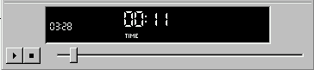
Stop
The player contains sound and video. These are not professionally produced but should prove helpful.

CREATE A NEW JOB ON THE COMPUTER
Before you do any processing on the computer you must first create the job on the computer. This consists of creating a subdirectory on the hard disk and then creating the actual CADD files.
- Start Microstation. You will see a screen similar to below.
- 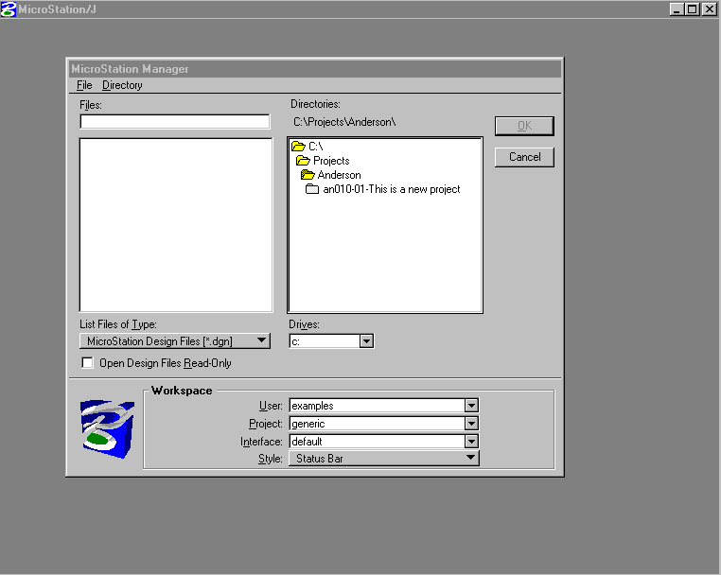
- In Region 1 Surveys we will store our projects in the H:\surveys\projects\county\projectname directory. In field office they are stored at c:\projects\county\projectname directory.
- On the right of the above box, navigate to the proper county then, go to DIRECTORY|NEW and type the path for the new project as shown below:
- 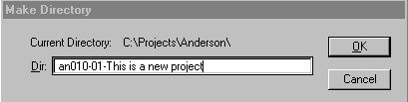
- Press OK.

- Go to FILE|NEW. Make sure seed file is set as shown on the bottom of the dialog box below.
- 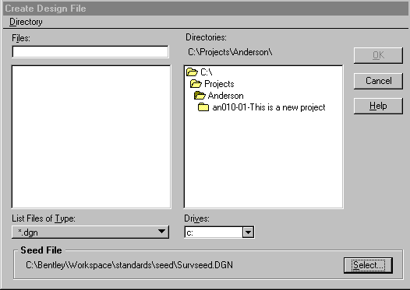
- If not press the select button on bottom right and choose it from the directory as shown below.
- 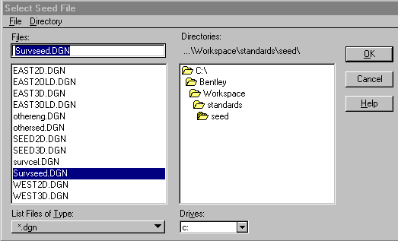

- Press OK and the box shown in step 7 returns. Change to the new directory you created and type the new file name as shown below.
- 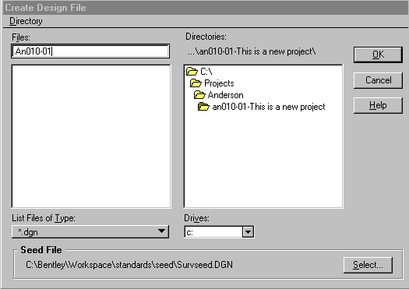

- Press OK.

- Geopak will start when Microstation starts.

- Go to project Manager. Press 
- Select PROJECTS|NEW on dialog shown below:
- 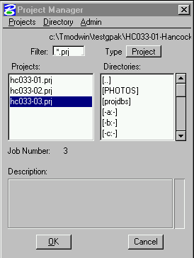
- Then enter project information:
- 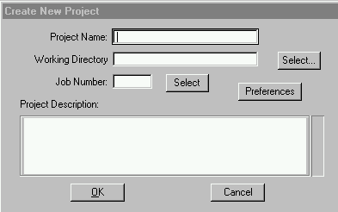
- Project Name is same as 8-character filename.
- Working directory is project directory.
- Job Number – Number assigned by Region Supervisor.
- Press PREFERENCES and set as below.
- 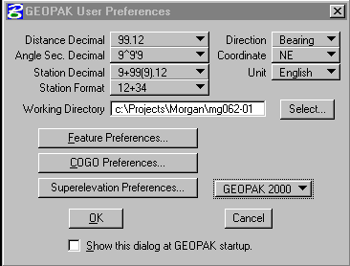
- Press Feature Preferences and set as shown
- 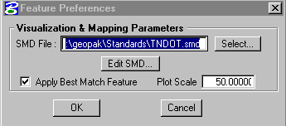
- Press Cogo Preferences and set as shown below
- 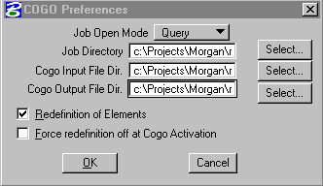
- Directories should be same as working directory as set is step 19
- Once Feature and Cogo preferences are set. Press Ok in step 24 dialog.
- Next dialog pops up.
- 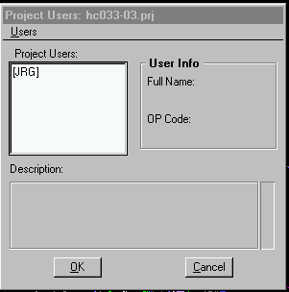
- Choose your username. If your name is not set up, go to USERS|NEW and create.
- The Geopak menu appears:
- 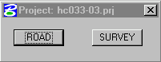

RETREIVING CONTROL POINTS FROM THE GPS DATABASE

- Open the Control Database. You should have an icon like this on your desktop.  If not, locate the file on your machine or on the network and open with Microsoft Access.
- The following opening menu will appear.
- 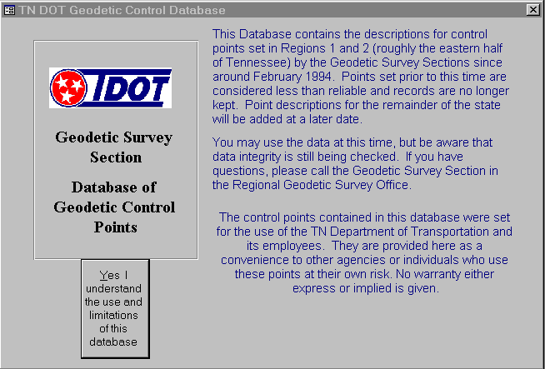

- Click the YES button and this box will appear.
- 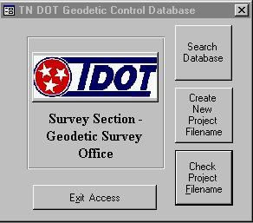
- Click Search and the following appears:
- 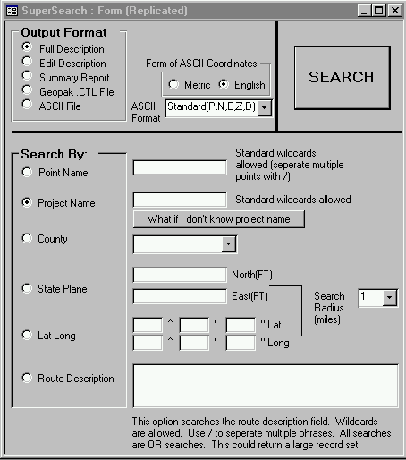

- For OUTPUT FORMAT select Full Description.

- For SEARCH BY select Project Name and type the project name in the blank.

- Click the SEARCH button and the description sheets are previewed for printing. Print the sheets for your records if needed.

- Repeat steps 8 & 9 except for OUTPUT FORMAT select Geopak CTL file. This will create a file for input to Geopak so you do not have to type all the control.

- Click SEARCH and you are prompted for the file name as shown

- 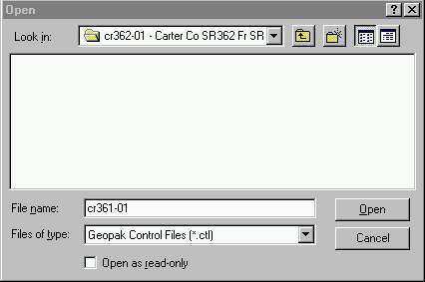

- Enter the filename and press OPEN. Make sure the directory is set correctly. The file is then stored for import to GEOPAK.

INPUTTING KNOWN GPS CONTROL

- Make sure Microstation file and Geopak file are set up in proper directory as shown on page 9. Open project manager and select user. You should see the following dialog
- 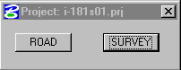

- Select SURVEY and you see this:

- 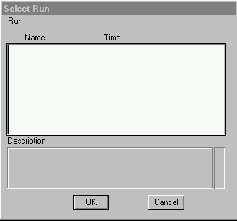

- Go to RUN | NEW

- 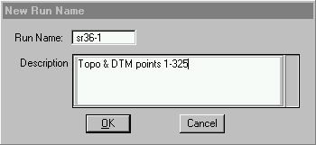

- Enter Data collector name for the first file you plan to dump from the data collector. You can do this in conjunction with the first dump if desired. Press OK

- The Run you just created will appear in the list. Highlight it and press OK. On the resulting dialog highlight CONTROL in the box at the left and you will see the following

- 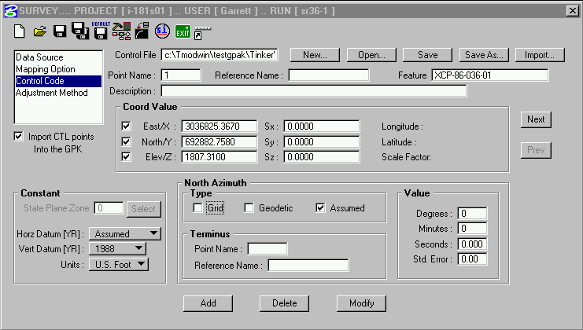

- Press OPEN (circled in red) and choose the file you created from the database on page 14. Set all other options as shown above. Review the points using the NEXT and PREV buttons. (circled in green) Look especially for proper point numbers.(yellow) The point numbers will have an “S” prefix. Note constant settings in lower left corner. (blue)

- Press save button to save the run settings (circled in pink). This will save the run for further processing in next section.

DUMPING AND PROCESSING FIELD DATA

- On the data collector, select the job you want to dump. Press T (TRANSFER)

- Set parameters as noted
DIRECTION: OUTPUT
FORMAT: SA
DUMP: ALL DATA
PORT: COM 1 or COM 2
PROTOCOL: KERMIT

- For the first file you dump create a new run as shown in previous section through step 9) above.

- Highlight DATA SOURCE and the dialogs will change. You will see a box and a flowchart as shown below:

- 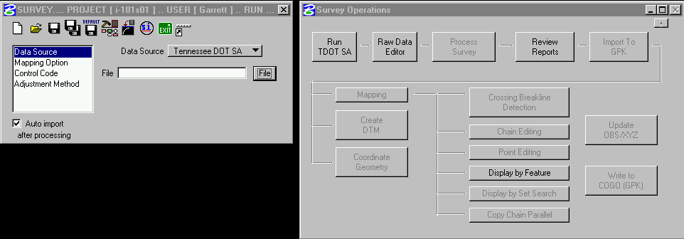

- Make sure data source is set to Tennessee DOT SA as shown then press Run TDOT SA on the flowchart. You will see the familiar SA2TRV program.
- 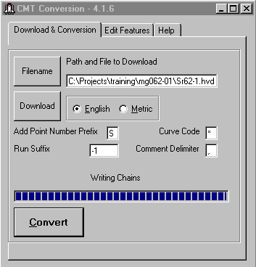

- Press FILENAME and select the path for download. Type the name of the file you are about to download with an .HVD extension. Choose English or Metric. Set point number prefix to “S” and curve code to “*” (asterisk). All our point numbers will start with “S” for example S100, S101, etc. This will keep survey points separate from design points and prevent overwriting points.
- Press DOWNLOAD. Kermit will start. Note: you must have created a file server.krm in the windows kermit directory that contains the proper setup configuration for the kermit program.
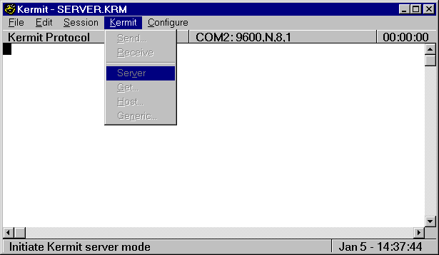

- On the Kermit menu, select KERMIT | SERVER
- On the data collector, Press F1 (GO)
(wait)
Press F1 (CONTINUE)
Press ESC
- Press CONVERT on the SA2TRV screen. The file is converted to Geopak .OBS format and stored in the project directory.
- Editing chains in the OBS file is very difficult. The SA2TRV program has been changed to allow you to edit the feature codes prior to OBS creation.
- After pressing convert or at any time you need to return to the file, click the EDIT FEATURES tab and you will see a spreadsheet type layout as shown below:
- 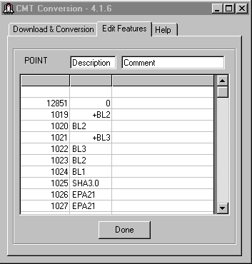
- To edit codes, especially the plus and minus signs, click in the row you wish to change then edit the point in the spaces on top. When finished, click DONE. The main tab will pop back. Press CONVERT to complete your changes.

- Close the SA2TRV and Kermit boxes returning to the Geopak survey manager.

- 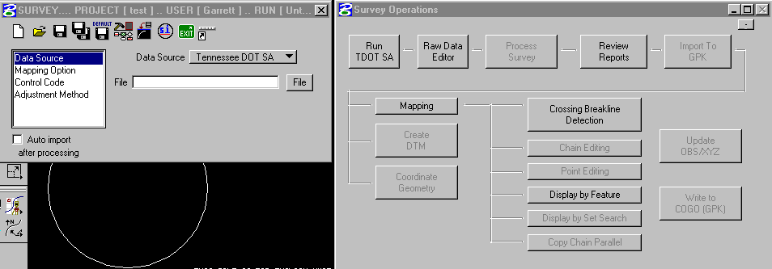

- Press the file button and select the file you just converted.

- Highlight MAPPING OPTION on the left and the box changes

- 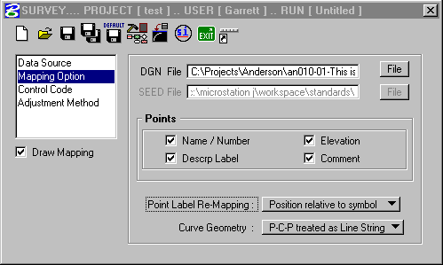

- Set all options as shown. Make sure the correct DGN file is listed in the DGN filename section.

- Highlight Adjustment Method and set all options as shown

- 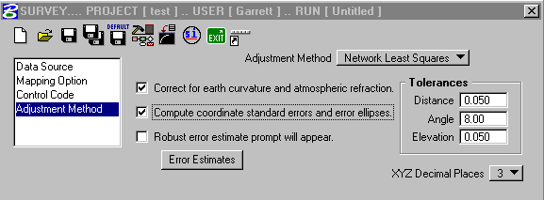

- On this same box press ERROR ESTIMATES and set all items as shown. This sets up the least squares adjustment settings.

- 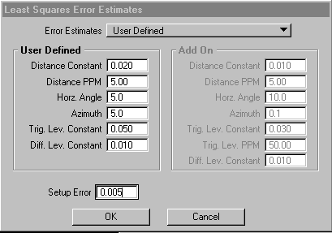

- Once all these are set. Highlight DATA SOURCE and you are back to here.

- Press RAW DATA EDITOR and review/correct field data. Data Editor is discussed below.

- Press Process Survey to compute and adjust coordinates.

- Press Review Reports to check for errors. Reports are discussed below.

- Repeat steps 29) through 31) until all errors are corrected.

- Press IMPORT to GPK to place the information in the drawing.

- During the IMPORT you may be faced with the following dialog:

- 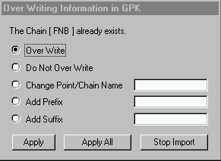

- This should only occur if you reprocess and re-import a run. You should overwrite all points and chains. Note: This assumes you are using the TDOT download procedure which automatically appends suffixes to chain names.

ADDING CONTROL FROM A PREVIOUS RUN TO CTL FILE
Often, you will set extra control in addition to the GPS points to see areas away from the survey centerline. For example, the backs of property or other items, which can’t be seen from main GPS control. If you use these in anther RUN other than the one in which they were set you have to add them to the CTL file. You can identify needed points in the Raw data editor. Look at the raw data. The first shot from each setup is the backsight point. Note this number, then prior to processing the RUN:

- Highlight CONTROL CODE on the survey manager dialog as shown above.

- Press Import.

- 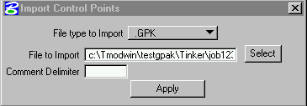

- Select the .GPK project file for this job. Press Apply.

- 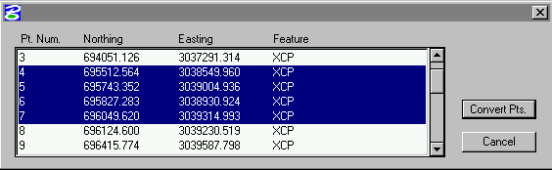

- Highlight the points you need to add and press Convert Pts.

- Back at the main dialog

- The points you added as control will be in the list.

- Press SAVE to save the points into the CTL file for current and future use.

RAW DATA EDITOR
The raw data editor is used to review and correct raw data prior to processing. The editor looks like this.
(1)(2)(3)(4)(5)(6)(7)(8)(9)

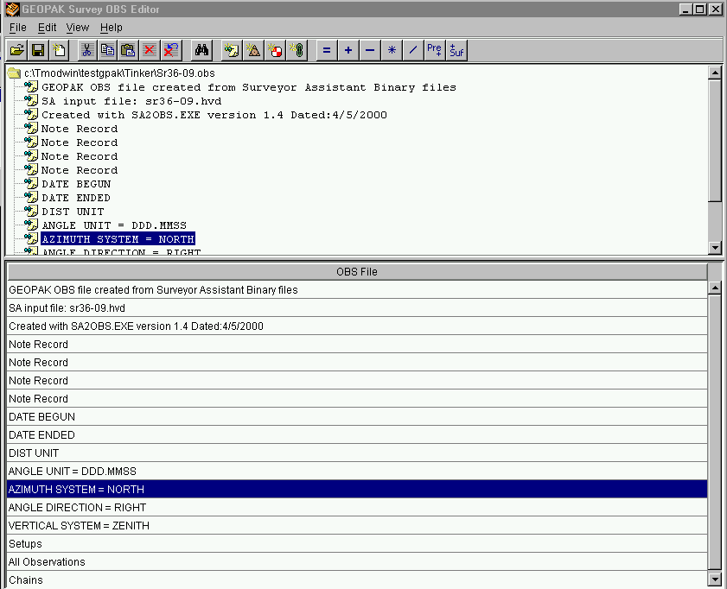

When you first open it you will see the usual notes you have always seen at the top of the file. Circled in red are the usual file and data manipulation buttons (new, save, open, cut, copy paste) along with delete and undo delete.
Numbered items are:
- Find button – Searches for a piece of text in the entire file or a certain field.
- New Remark – Adds a new note to the file.
- New Setup – Adds manual data to the file.
- New Observation – Adds manual data to the file.
- New Chain – Adds manual data to the file.
- Replace – Replaces all highlighted data with whatever you tell it.
- +,-,*,/ - Scales highlighted numerical data either by (+) adding a constant value to all, (-) subtracting a constant value, (*) multiplying all by a factor or (/) dividing all by a factor.
- Prefix – Adds a prefix to all highlighted fields
- Suffix – Adds a suffix to all highlighted fields.

If you scroll down on the top part of the display you will see different views of the data. Shown here is the setups view. Data is arranged based upon every setup of the instrument.
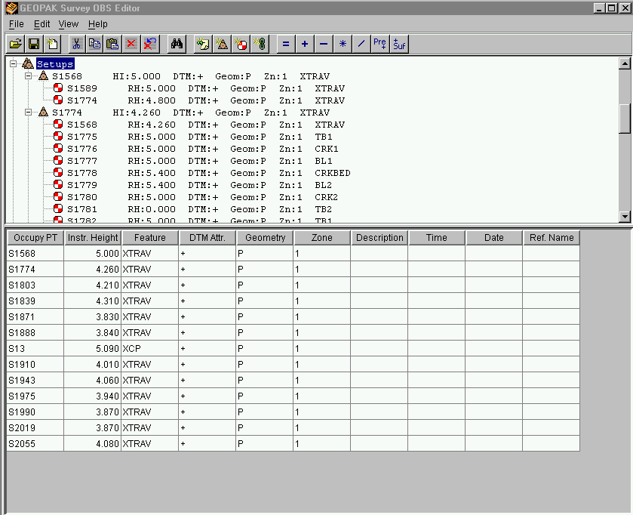

If you highlight SETUPS on top the bottom pane shows all the different setup. If you highlight one of the setup numbers in the top pane, the bottom pane will display all the observations from that point so that you may edit them if needed. This is shown below.
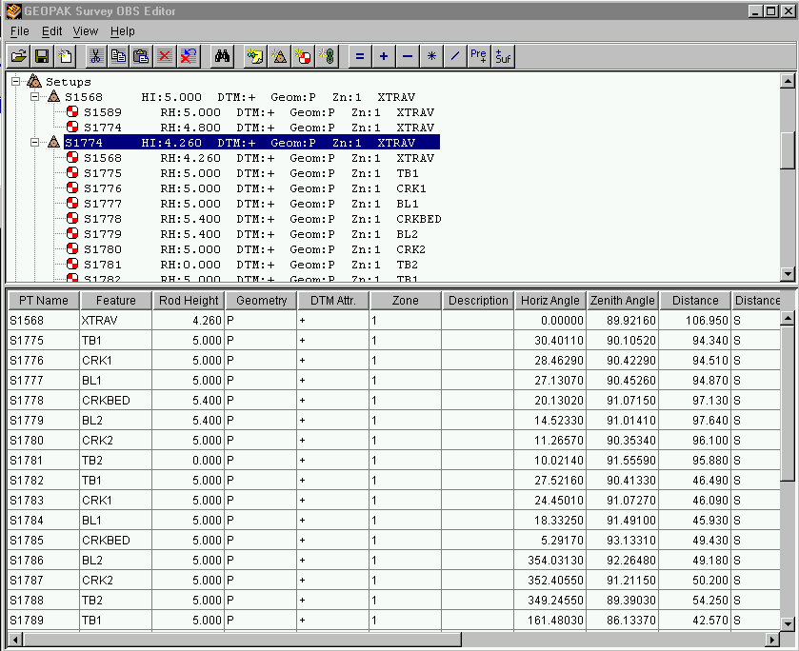

Note the bottom pane now shows all the different shots in a format similar to the Terramodel Fieldd editor. To correct data such as HI double click the cell needing correction and type the new data. Click another cell to update the change then save the file.

Don’t forget the helpful buttons on top. For example, if you accidentally collect data in metric and it should have been English, you can highlight an entire column of distances and multiply them by 3.280833333.

INTERPRETING LEAST SQUARES ADJUSTMENT REPORTS
After you process your data, you should look at the reports that are generated. They will reveal a great deal about the quality of your survey and can help isolate problems.

Press the “review reports button shown above and you will see this:
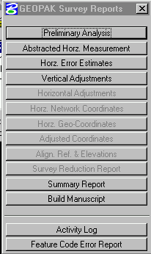
You should look for the following:
- Preliminary Analysis Report 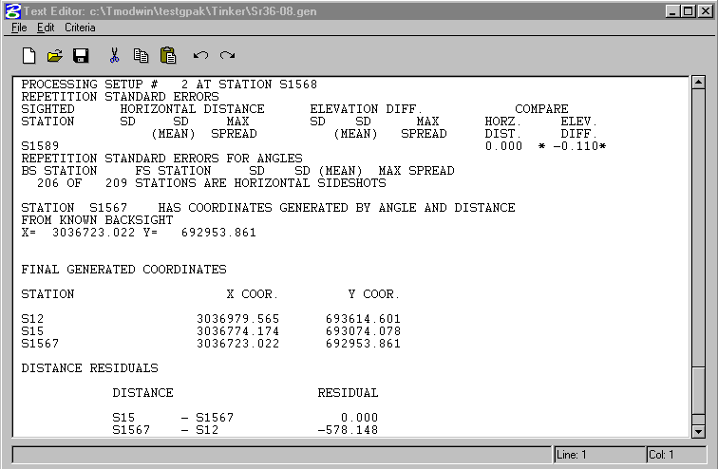
Many errors are marked with an asterisks. Scroll down the report and check these errors. In the example above there is one of these errors showing near the top of the screen. It indicates a difference in the elevation of a point. This tells us that point 1589 was shot from two different points and the computed elevation is different from the two observations. A bad vertical angle or bad HI can cause this. Similar errors can occur in the horizontal as well.
This example also shows, at the bottom, a very high residual number. The residuals should be 0.00. This high residual from point 1567 to point 12 is an indication than a bad measurement has occurred.

- Summary Report
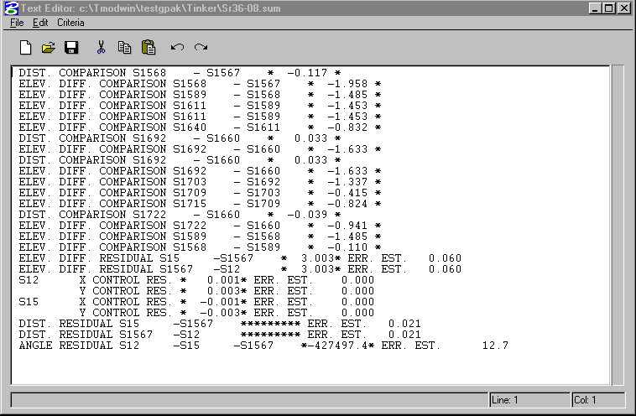
The summary report is a list of all the errors found during processing. It includes all the errors in the Preliminary report in a summarized table. If this report is blank and the Standard Error Unit Weight is good during processing then you have a good run.

- Feature Code Error Report
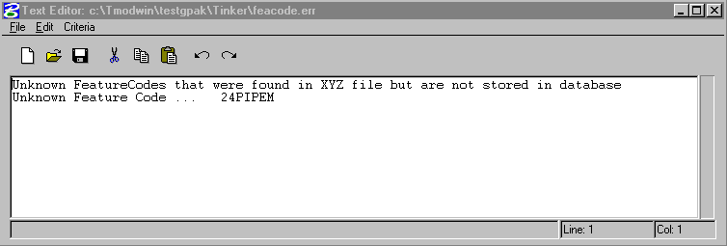
This report lists any field point codes that are unknown to Geopak. In this case, 24PIPEM was unknown.

CHECKING AND CORRECTING BREAKLINES

- 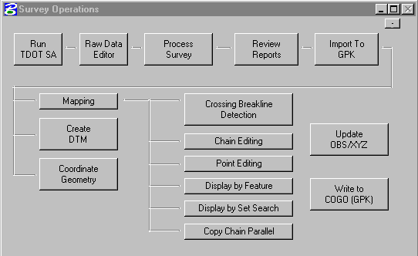
- On the Survey flow chart press “Crossing Breakline Detection” as shown above.
- 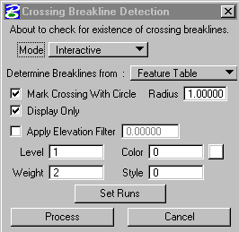
- Set the dialog as shown. Press “Set Runs”
- 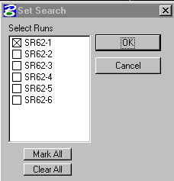
- Select the run or runs you just downloaded. Note: you will normally do one run at a time to make the work easier, but remember, you could have crossings from one day to the next so you should at some point process all runs at once.

- The program will chack all the breaklines and show this dialog.
- 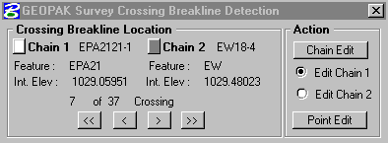
- In this case the program found 37 crossings. The drawing will be zoomed in on the first one with a circle around the point where the crossing occurs. I have moved the arrows on bottom to crossing number 7 which is an EP line (chain 1) crossing an EW (chain 2) line.
- The graphics highlighted by the tool is shown below:
- 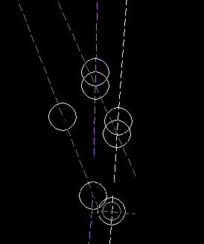
- The program placed the circles which are temporary to show where the crossings occur. It also temporarily changes the colors of the lines to make it easier to identify which lines are being referenced.
- In this case, this is the area at the end of an existing bridge where the EP extends up onto the bridge. The EP continues all the way across so what we need to do is beak the EP into three chains (one each side of the river which are included in the DTM and one across the river which is not)
- Unfortunately, I don’t know how to do this. If you do, please call.
- You can choose to edit one or the other of the chains or to edit a point.

- The chain editor is located below:
- 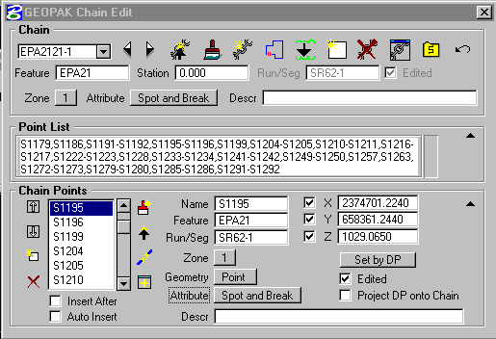
- The point list shows all the points include in the chain.
- At the bottom, the Chain Points section is the same list but when you highlight the point number a white box snaps onto the point in the graphics view so you can change the point.
- A common fix is to manually move the point a very small amount by pressing the “SET BY DP” button and picking where to move the point. Select the “PROJECT ONTO CHAIN” checkmark to force the moved point to slide along the chain.
- Another common fix is to insert a GAP into the chain with the circled button or remove a point from the chain with the “X” button.

IMPORTING AERIAL MAPPING FILES TO GEOPAK
- See DTM section above for DTM Import
- Reference topography.

DUMPING ZEISS DIGITAL LEVEL AND ADJUSTING LEVEL NOTES

- How do we incorporate with Geopak???
- Connect the level to the dumping cable by the port on the bottom of the level.
- Open the Zeiss dumping program.
- 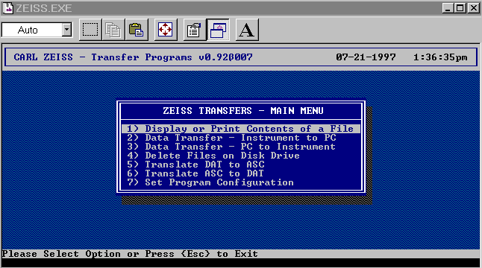Select Data Transfer Instrument to PC.
- 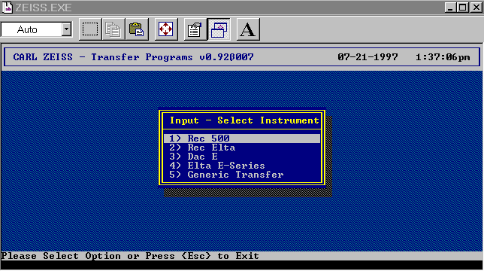
- Select REC 500.
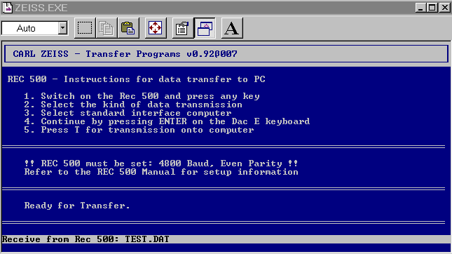
- 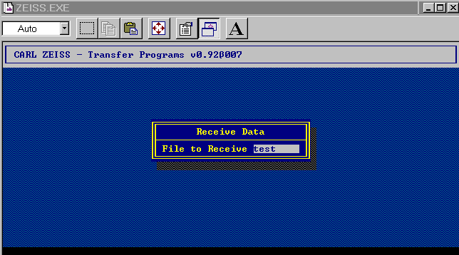
- Enter a filename. Use the same filename as you project name. The program will append a .DAT extension.
- At this screen go to the level and press ON, Then MENU, then DATA TRANSFER, then INTERFACE 1, then DiNi to PERIPHERY. Then ALL. The level loop will be dumped.
- On the computer Press ESC until the dump program is exited. The adjustment program will start.
- Enter the name of the dumped level loop without the extension. Enter the project directory. The loop will be adjusted with pre and post balanced closure reports printed.

DIGITAL TERRAIN MODELS
The digital terrain model consists of two parts, the aerial data if available and field data.

If you have aerial survey DTM data:
- Open the aerial surveys file containing DTM data.
- Open the DTM Tools menu shown here: 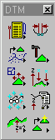
- If you do not see this icon box on your screen go to APPLICATIONS|GEOPAK ROAD|DTM TOOLS.
- Press this button to extract the information from the graphical DTM. You will see this.
- 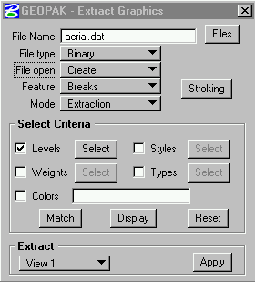 Set as shown with an appropriate filename. Press the SELECT button next to levels and set as shown here.
- 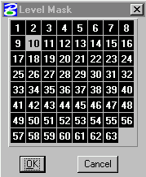 Then press APPLY.
- Change the feature from breaks to spots and file open from create to append as shown here
- 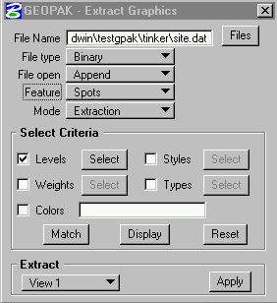
- And change levels as shown here:
- 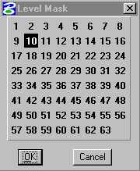 Then press APPLY
- Press this button  to build triangles and you will see this.
- 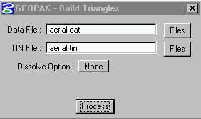 Use the same filename you created in the DAT file and press PROCESS.
- 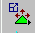 This button is used to edit DTM data. This should not be required for aerial files since they have been checked by the Aerial Surveys Office.
- This button displays various reports about the DTM
- Press this button to view contours, triangles etc. for DTM checking. You will see this
- 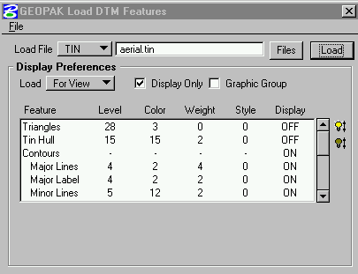
- Press FILE|OPEN and select a file named TDOT.LPF which will load the most common settings. You can then turn on and off other desired display properties as required.
- Go to section for FIELD DATA DTM

FIELD DATA DTM

- Press CREATE DTM on the flowchart an you will see this:
- 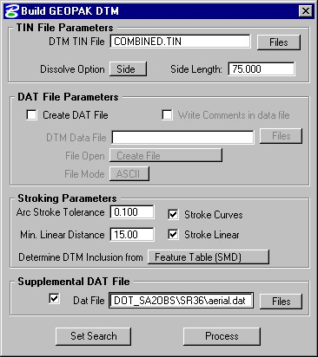
- Enter a name for the DTM in the top line. Set other options as shown.
- Set the supplemental DAT file to the DAT you created during the aerial survey import step. If there is no aerial survey remove the check from Supplemental DAT section.
- Press the “SET SEARCH” button and choose which runs you want to see, normally all runs.
- Press this button to view contours, triangles etc. for DTM checking. You will see this
- Press FILE|OPEN and select a file named TDOT.LPF which will load the most common settings. You can then turn on and off other desired display properties as required.

THREE PORT VIEWER

Another powerful tool for checking the DTM is the Three-Port Viewer. It allows you so view contours, profile and existing ground cross-sections at the same time.

CREATING ALIGNMENTS
Generating alignments
Labeling alignments

PROFILES
- Click DTM | CREATE PROFILE The following box will appear:

SIDEROAD PROFILES
- Create alignment for side road.
- If a side road goes to the left then start the stations away from the mainline and station towards the mainline. If the side road goes to the right then start stations at the mainline.
- Use the same instructions as for mainline profile.

STAKEOUT

- Alignments
- ROW

R.O.W., PROPERTY, AND AREAS

Parcels, COGO,
The following are general guidelines for establishing existing R.O.W., property lines and calculating areas.

R.O.W. and Property:

AREAS: Replace with Parcels – Export to Excel????

CREATING ACQUISITION TABLES
Excel and linking & embedding
Placing Owner Names
Extract information from parcels to a table????Excel????
The following is the procedure to create an acquisition table:
- Create an input file with the text editor of your choosing. Filename must have .ACQ extension.
  - Enter Property information one tract per line as follows:
  - COLUMNS ITEM
1-4 tract no.
5-95 property owner name
96-103 tax map number
104-111 parcel number
112-119 deed book number
120-127 deed book page number
128-135 area left of centerline (Acres to 3 decimal places)
  - area right of centerline (Acres to 3 decimal places)
144-151 area acquired left
152-159 area acquired right
160-167 drainage easement
168-175 slope easement
  - construction easement

  - If a tract has multiple deed references then create two or more lines with all items blank except the deed references that are different. You may also continue a long property owner name to the next line.

GENERAL INFORMATION ABOUT PLOTTING

The following are general rules and suggestions for plotting with the Geopak and the HP 1050C plotters.

PLAN SHEETS
The plot box size to fit on a standard sheet border is 21in by 31.5in (53.3cm by 69.8cm). Following is a summary of levels that are used in Surveys.

LEVEL STRUCTURE
See “CADD GUIDELINES” for a complete listing including proposed layout levels.

Standard File Parameters: Survey Information
LV | Information contained on level |  | CO | WT | LC | TX
1 | Existing Ground Profile
Profile: Existing Ground Profile |  |  | 15 | 2 | 3
2 |  | TEXT FOR LEVEL #1
3 |  | SURVEY CONTROL and GRID WITH TEXT
GPS Points |  |  | 1 | 2 | 0 | .100
Reference Points |  |  | 1 | 2 | 0 | .100
Benchmarks |  |  | 1 | 2 | 0 | .100
Grid Tics |  |  | 1 | 2 | 0 | .100
Grid Tic Labels |  |  | 1 | 2 | 0 | .100
4 |  | INDEX CONTOURS (with text) | 2 | 2 | 2 | 0.100
High Points - Spot Elevations |  |  | 2 | 2 | 0 | .100
5 |  | INTERMEDIATE CONTOURS | 12 | 0 | 3
6 |  | DRAINAGE MAP DATA
Area Shapes |  |  | 3 | 4 | 0
Text |  |  | 3 | 2 | 0 | .100
7 | EXISTING TRANSPORTATION FEATURES |  | 11 | 2 | 3 | 0.100
Airport runways |  |  | 11 | 2 | 3
Bikeways |  |  | 11 | 2 | 3
Parking lots |  |  | 11 | 2 | 3
Railroads & switch stands |  |  | 11 | 2
Driveways |  |  | 11 | 2 | 3
ROADWAY:
Curb/Curb & Gutter |  |  | 11 | 2 | 3
Edges of roads |  |  | 0 | 4 | 3
Medians (flush or raised) |  |  | 11 | 2 | 3
Shoulders (outside edge of stabilized shoulders) |  |  | 11 | 2 | 3
Sidewalks |  |  | 11 | 2 | 3
Trails |  |  | 11 | 2 | 1
Tunnels (highway, pedestrian, railroad, etc.) |  |  | 11 | 2 | 3
8 |  | EXISTING ROADSIDE BARRIERS AND TEXT FOR LEVEL #7 | 11 | 2 | 0 | 0.100
Private drive text |  |  | 11 | 2 | 0 | .100
Roadway text |  |  | 0 | 2 | 0 | .100
Guardrail |  |  | 11 | 2
Guardrail terminals |  |  | 11 | 2
Impact attenuators |  |  | 11 | 2
Jersey barrier |  |  | 11 | 2 | 3
Retaining walls (roadway & noise) |  |  | 11 | 2 | 3
10 |  | PROPERTY OWNERS & TRACT NOs.
Property owners |  |  | 10 | 7 | 0 | .175
Tract numbers |  |  | 10 | 4 | 0 | .140
Tract no. ellipse |  |  | 10 | 4 | 0
Aerial DTM: Random Points
11 | EXISTING NON-TRANSPORTATION FEATURES
Athletic fields |  |  | 1 | 2 | 0
Buildings
Dams & Spillways |  |  | 1 | 2 | 0
Dikes, levees, & docks |  |  | 1 | 2 | 0
Cemeteries |  |  | 1 | 2
Debris & Storage Piles |  |  | 1 | 2 | 0
Fence lines |  |  | 1 | 2
Flagpoles |  |  | 1 | 2 | 0
Patios & decks |  |  | 1 | 2 | 0
Quarries & pits |  |  | 1 | 2 | 0
Retaining walls (residential & commercial) |  |  | 1 | 2 | 0
Rip-rap |  |  | 1 | 2
Sidewalks (private) |  |  | 1 | 2 | 0
Steps |  |  | 1 | 2 | 0
Stone fences & rock walls |  |  | 1 | 2
Stream gauges |  |  | 1 | 2 | 0
Swimming pools |  |  | 1 | 2 | 0
Tanks (fixed) |  |  | 1 | 2 | 0
Towers |  |  | 1 | 2 | 0
Well houses |  |  | 1 | 2 | 0
Areas under construction |  |  | 1 | 2 | 0
12 | TEXT FOR LEVEL #11 |  | 1 | 2 | 0 | .100
 |  | Aerial DTM: Obscure Lines
13 |  | POLITICAL BOUNDARIES
City & village |  |  | 1 | 2
County |  |  | 1 | 13
State |  |  | 1 | 17
14 |  | TEXT FOR LEVEL #13 | 1 | 4 | 0 | .14
15 | EXISTING R.O.W. & PROPERTY LINES
Easement lines |  |  | 10 | 4
Right-of-Way lines |  |  | 10 | 4
Property Lines |  |  | 10 | 2
Aerial DTM: Exterior Lines
16 | TEXT FOR LEVEL #15 |  | 10 | 2 | 0 | .120
R-O-W markers |  |  | 10 | 2
17 | EXISTING NATURAL DRAINAGE FEATURES (with text)
Rivers, streams, creeks, & ponds |  |  | 4 | 2 | 6
Irrigation ditches |  |  | 4 | 2 | 6
Text |  |  | 4 | 2 | 0 | .100
Profiles: HW marks |  |  | 4 | 2 | 0 | .120
18 |  | EXISTING VEGETATION FEATURES (with text) | 8 | 2 |  | .100
19 | EXISTING BRIDGES & DRAINAGE
Bridges (including non-drainage bridges) |  |  | 3 | 4 | 3
Pipes & box culverts (side drains & cross drains) |  |  | 3 | 2 | 3
End treatment (endwalls, concrete aprons, etc.) |  |  | 3 | 2 | 3
Profiles: Existing Bridge Opening
Cross-Drains, Culverts |  |  | 3 | 2 | 3
20 | TEXT FOR LEVEL #19 & #21 |  | 3 | 2 | 0 | .100
21 | EXISTING STORM DRAINAGE
Storm sewer pipes & box culverts |  |  | 3 | 2
Structures (catchbasins, drop inlets, etc.) |  |  | 3 | 2
Storm sewer manholes, etc. |  |  | 3 | 2
Profiles: Catchbasins, Manholes & connecting pipes |  |  | 3 | 2 | 3
Aerial DTM: Breaklines |  |  | 8 | 2 | 0
22 | DRAINAGE FIELD POINTS |  | 3 | 2 |  | .100
Includes pipe & box culvert invert elevations.
23 | EXISTING SIGNS & TRAFFIC CONTROL (with text)
Text |  |  | 7 | 2 | 0 | .100
Overhead signs |  |  | 7 | 2 | 0
Signal poles |  |  | 7 | 2
Traffic signals |  |  | 7 | 2
Traffic control devices |  |  | 7 | 2
Striping |  |  | 0 | 2 | 0
Signposts |  |  | 7 | 2
Barricades & barrels |  |  | 7 | 2
Billboards |  |  | 7 | 2
Historical markers |  |  | 7 | 2
24 | TRANSPORTATION FEATURES FIELD POINTS
25 | EXISTING UTILITIES (with text)
Electric |  |  | 5 | 2
Cable TV |  |  | 8 | 2
Guy wire |  |  | 7 | 2
Lights (pole-mounted) |  |  | 5 | 2
Substation |  |  | 5 | 2 | 3
Telephone |  |  | 8 | 2
Transmission lines & towers |  |  | 5 | 2 | 3
Utility boxes (pole-mounted) |  |  |  | 2 | 3
Utility poles |  |  |  | 2
Utility poles (with lights) |  |  |  | 2
Fire hydrants |  |  | 6 | 2
Gas lines |  |  | 7 | 2
Manholes (all utilities) |  |  |  | 2
Sanitary sewers |  |  | 13 | 2
Utility boxes (self-supporting) |  |  |  | 2 | 3
Utility valves (all types) |  |  |  | 2
Utility meters (all types) |  |  |  | 2
Water lines |  |  | 4 | 2
Text |  |  |  | 2 | 0 | .100
Profiles: UG Utility profiles
Profiles: OH wire crossings
26 | GEOPAK PARCELS AND ROW/PROPERTY FIELD POINTS |  | 1 | 2
27 | NON-TRANS FIELD POINTS |  | 1 | 2 | 0 | .100
28 | NATURAL DRAINAGE FIELD POINTS
29 | BREAKLINES FIELD POINTS |  | 1 | 2 | 0 | .100
30 | MISC FIELD POINTS
31 | PROPOSED CENTERLINE GEOMETRY
Main line, side roads, & detours |  |  | 6 | 10 | 0
Geometry: tangents & curves |  |  | 6 | 10 | 0
Geometry: curve tangents |  |  | 6 | 7 | 0
Points (PC, PI, PT, TS, SC, POT, etc.) |  |  | 6 | 7 |  | .140
Equations |  |  | 6 | 7 |  | .140
32 | TEXT FOR LEVEL #31
Main line, side roads, & detours |  |  | 6 | 2 | 0 | .120
Station ticks |  |  | 6 | 7 | 0
Station text (500-ft / 100-m labels) |  |  | 6 | 10 | 0 | .200
Bearings |  |  | 6 | 4 | 0 | .120
Equations |  |  | 6 | 4 | 0 | .120
North arrow |  |  | 6 | 7 |  | .200
Match lines |  |  | 6 | 10
Match line text |  |  | 6 | 2 |  | .120
Centerline intersections |  |  | 6 | 4 | 0 | .140
33 | PROPOSED CURVE TEXT
Curve information text |  |  | 6 | 2 | 0 | .120
Point Text (PC, PI, PT, TS, SC, POT, etc.) |  |  | 6 | 2 | 0 | .120
40 | HYDRAULIC CONTROL DATA (BRIDGE SURVEYS) (with text)
Flood Plain section lines |  |  | 6 | 2 | 0 | .100
Stream profile lines |  |  | 6 | 2 | 0 | .100
Top of Bank lines |  |  | 4 | 2 | 0 | .100
Profiles: Stream Profile & Xsection
61 | SHEET BORDERS
62 | SHEET BOXES (with text)

REFERENCE DIAGRAMS
There is a TML (RDIAG) that will assist you in drawing reference diagrams.

????????????????????

PLACING SYMBOLS and TEXT
Most symbols will be placed in the drawing automatically by the procedures on page 29. However, there will be instances where you will want to place one manually and you will have many occasions to place

PLACING PIPES ON PROFILES
- WPIPONPR (ENTER)

PLACING CULVERTS ON PROFILES
- WCVONPRO (ENTER)

PLACING OH WIRES ON PROFILES
- WOHONPRO (ENTER)

PLACING BENCHMARKS ON PROFILES
- WBMONPRO (ENTER)

lABELING CATCH BASINS AND MANHOLES plAN AND PROFILE
Inverts labeled Auto
Table Creation?
Profile drafting ?

DRAINAGE MAPS

Attach scanned image of appropriate TVA quad maps:
- On the Microstation menu go to FILE|IMAGE MANAGER
- 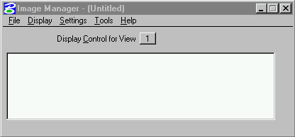
- Go to FILE|OPEN
- 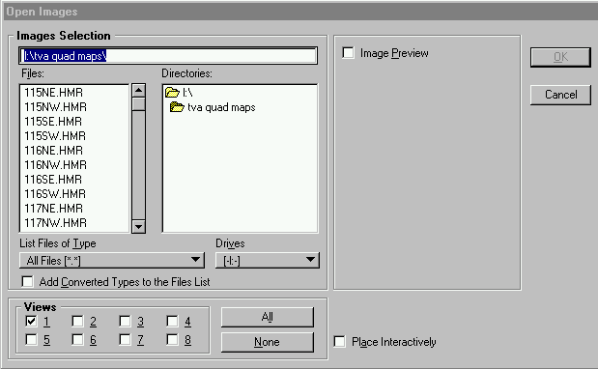
- Select the appropriate file or files and press OK.
- The images will come into the drawing as a backdrop but may not be in the proper location. Highlight each map that is attached and then press FILE|PROPERTIES|LOCATION and you will see this
- 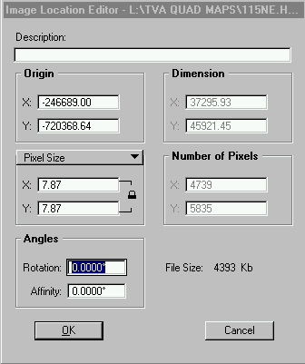 Look in the .TFW file with the same name as the TVA map you used. The X and Y coordinates of the map are listed here multiply the coordinates by 3.2808333 to convert to metric and by the DAF factor of your project and place these coordinates in the X and Y slots. Set the pixel size to 7.87
- You still may have to manually move the image to exactly line it up on your project.
- Once the maps are set up you will see your survey drawn on top of the maps.
- Then using the contours as a guide draw a PARCEL around each drainage area. See above for instruction to create the parcel. Why use a parcel? Because you can then automatically extract the area.

DRAINAGE INFO
Place pipe or bridge cells
Fill in the information.

BRIDGE SURVEYS

The following procedures are to produce a finished bridge survey to be sent to structures by the designer. When I speak of bridge survey, I mean the information required for water crossings in excess of 500CFS

The following information constitutes a bridge survey:
1. Present layout information at the bridge site.
2. Centerline profile information at the bridge site.
3. A stream profile showing, stream bed, top-of-water, top-of-bank.
4. An upstream section, a downstream section and a confined section all of which clear high-water. Note: Most times the confined section is located at the centerline profile. If this is the case make a note as to this fact on the stream profile.
5. A sketch of the existing structure.
6. A contour map of the bridge site at plan scale and 1' or 0.2m contours.
7. The drainage information as noted above.
To get the upstream section, downstream section, and stream profiles:

- Locate the lines in the field. Note that codes CRKBED, UP, and DOWN are for use for the streambed and upstream and downstream sections respectively. If the DTM is large enough then you do not have to profile the upstream and downstream section in the field. The office operator can simply strike a line at the place where he wants a section.
- Profile each of the lines (creek bed, top of bank, and top of water).
- See the page on PROFILES and follow similar instructions to set up the plot boxes and sheets.

PROCEDURE FOR ADDITIONAL INFORMATION
The following procedure will facilitate collecting and turning in additional information. You must only turn in the added information.

FILLING OUT WEEKLY REPORTS
??????Following are instructions for using the Excel spreadsheet for filling out weekly reports:

- To begin a new report for a new project, open EXCEL and load the file BLANK WEEKLY PROGRESS REPORT.
- Then go to FILE|SAVEAS and save the file to a new filename then fill in the information for the new project. Be careful not to simply SAVE or you will have information saved into the blank file.
- Below is what the form will look like when you load it:
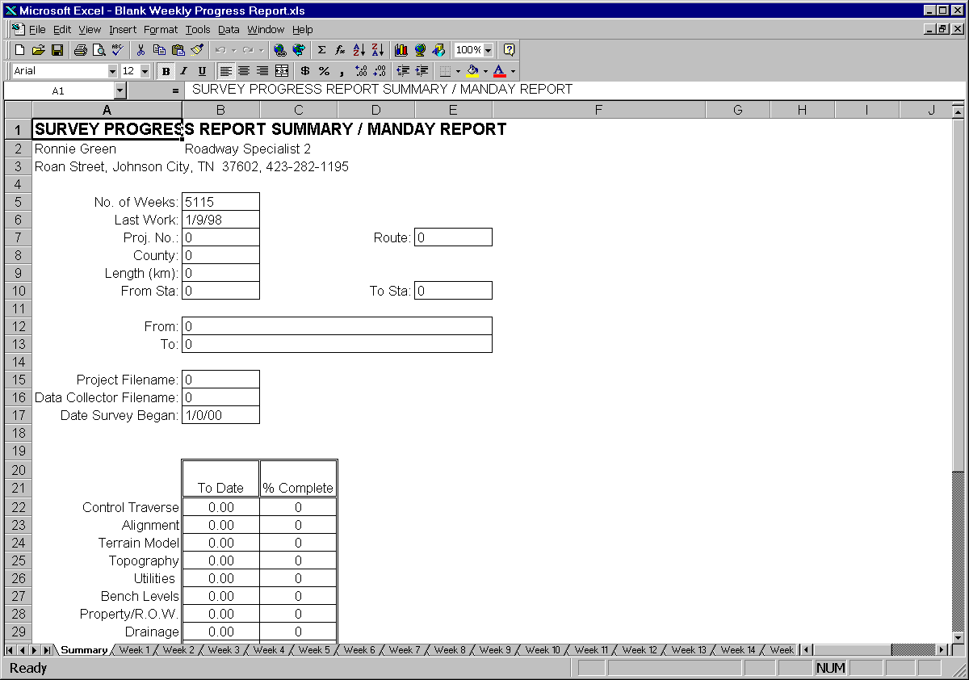

- The spreadsheet consists of 54 separate sheets. One summary sheet, 52 weekly report sheets and a misc. sheet.
- The summary sheet requires no input. It is intended for the recipient of the report to quickly find the latest information and print if desired rather than having to sift through the weekly sheets to find the last one that is filled in.
- The weekly sheets are for the field engineer to fill in his weekly report information. There are 52 weekly sheets. This will allow a project to extend for up to a year, which should cover most projects. If you only need a few weeks, that is ok. Just use the ones you need but do not delete the remaining sheets. The summary sheet depends on having all sheets intact.
- On the weekly sheets, anything marked in red requires input from the engineer. Below is a picture of a weekly sheet:
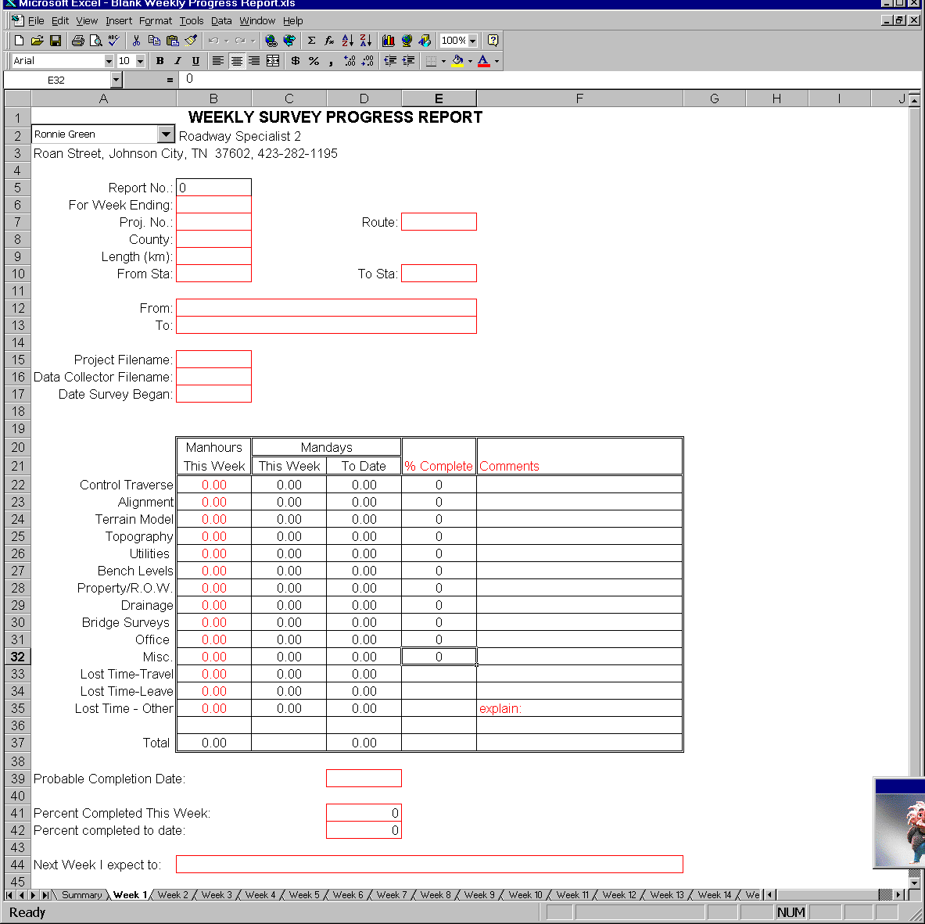
- The WEEK 1 sheet requires the input of the project description, etc. then these items are automatically carried over to all the remaining sheets.
- On each of the weekly sheets the time worked is input in man-hours (for easier input by the engineer) and recomputed by the computer to man-days in the next two columns.
- Totals for man-days are carried forward to all subsequent weeks requiring only the input of the time worked in any particular week.

- An estimate of percent complete for each item is required input each week as well as an estimate of the percent of total completed that week. These percentages are also carried forward.
- The MISC sheet is used to input names, titles, addresses and phone numbers of the engineers. These are used by the drop down box on WEEK 1 to input the information by simply picking your name from the drop down list. These items are carried forward to all sheets.
- If your name is not in the list just go to the MISC sheet and add your name to one of cells A1 through A25, your title to B1 through B25, and your address/phone to C1 through C25. Save the spreadsheet and you will appear in the drop down list.
- The report number is calculated based on the date you input each week and the beginning date of the survey.
- Project filename is the Terramodel project file name assigned to the project. (for future reference)
- The data collector file name is the base file name used for data collection. (for future reference)
- Make sure to input the date survey began on WEEK1 and it will be carried over to all other sheets.
- An estimate of the probable completion date must be made each week. It will be carried forward to all subsequent sheets.

WORKING WITH ZIP FILES
When large files are sent via Email or over the Internet, they are often compressed so that they will transfer faster. The oldest and best known program for compressing these files is called PKZIP. The files created by this program have become the defacto industry standard. The files created by this program and others that support the PKZIP format are known as ZIP files and usually have an extension of .ZIP. When you see a file with .ZIP extension then you can assume that it is a PKZIP format file and that the files contained within are compressed. A single ZIP file may actually contain many individual files.

If you need to create a ZIP file:
- Double click the WINZIP icon. You will see the WINZIP program similar to step 6 below.
- Open Windows Explorer and drag the files you want to compress to the WINZIP program box. The following will pop up.
- 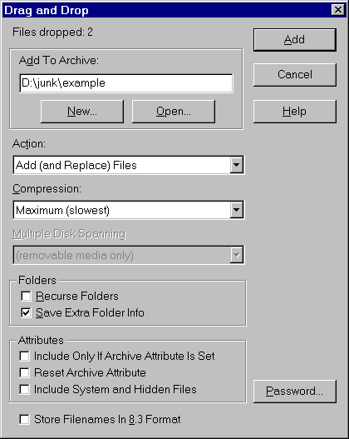
- Enter the path and filename to the Add to Archive box.
- Set the other settings as shown. Press Add. You will see the files in the WINZIP window as shown.
- 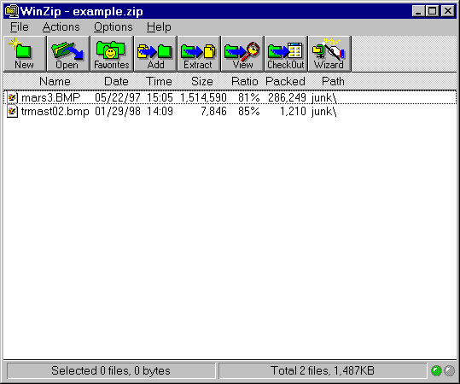
- When you send the file, you will send the ZIP file, in this case EXAMPLE.ZIP.
- UNZIPPING A FILE.
- If you receive a ZIP file you must unzip it before you can use the files contained inside.
- I have set up your machines so that if you download a ZIP file on the internet the WINZIP program will automatically start. If you receive a ZIP file by Email then right click the file and choose OPEN. Either way you will see the WINZIP program similar to step 6 above.
- Press the EXTRACT button and the following box will pop up.
- 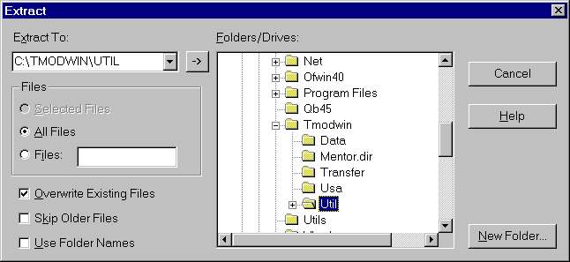
- Enter the path where you want to store the files. Make sure ALL FILES is checked and press OK. The files will be unzipped to the directory you specified.
- Sometimes you might receive what is called a self-extracting ZIP file. These have an .EXE extension. Save them to the directory where you want to extract the files. Then double click the .EXE file you saved. The files will be extracted to the same directory.

CORRESPONDANCE

Property Owner Interview Form
See Appendix H for sample form

- In Microsoft Word, open the file PFORM.DOC. This document has forms set up. The cursor will be in the first form field which is the first part of the project number.
- Fill in this part then press the TAB key to move to the next field.
- Continue until all fields are filled. You will fill in only the section with the project information.
- Press FILE|PRINT to bring up the print dialog. Enter the number of copies you think you will need then Press OK.
- Send these prints to the field for interviews with property owners.

APPENDICES

APPENDIX A - POINT DESCRIPTORS

TRANSPORTATION FEATURES
BE......Business Entrance
BIKE....Bike Path
CU......Curb
DR......Driveway
EP......Edge Of Pavement
FE......Field Entrance
GRM.....Guardrail Median
GRL.....Guardrail Left
GRR.....Guardrail Right
IMP.....Impact Attenuator
JB......Jersey Barrier
MED.....Median
PK......Parking Lot
RD......Edge Of Road
RR......Railroad
RRSS....Railroad Sw. Stand
RWAY....Airport Runway
RWT.....Ret. Wall
RWTWF...Ret. Wall W/Fence
SWT.....Sidewalk
SH.....Edge Of Shoulder
TRAIL...Trail
TUN.....Tunnel

XHRAMP..Handicap Curb Opening
XRRSW...Railroad Switch

NON-TRANS FEATURES AFLD....Athletic Field
BC......Building
CG......Cattle Guard
CEM.....Cemetery
FN......Fence
GATE....Gate
GRAVE...Grave
PIT.....Quarry Pit
ROCKW...ROck Wall
RW......Retaining Wall
RWP.....Ret. Wall
RWPWF...REt. Wall W/Fence
SEPTIC..SEptic Field Line
SW......Sidewalk
SWP.....Sidewalk
TOWER...Tower

XBLDR...Boulder
XFLAG...Flag Pole
XFP.....Fence Post
XMB.....Mail Box
XSATLIT.Satellite Dish
XSEPTIC.Septic Tank
XWELL...Well

DRAINAGE
APRON...Paved Apron
BRI.....Bridge
CRK.....Creek
CRKB....Creek Bed
CV......Culvert
DAM.....Dam
DIKE....Dike
DIT.....Paved Ditch
DOWN....Downstream Flood Section
EW......End Wall
GAGE....Stream Gage
HW......Highwater line
LAKE....Lake
LEVEE...Levee
PIER....Bridge Pier
PIPE....Pipe
POND....Pond
RPDS....Rapids/Waterfall
RRAP....Rip-Rap
RIVER...River
SINK....Sinkhole
SPILL...Spillway
STS....Storm Sewer
TB......Top Of Bank
UP......Upstream Flood Section

XCB.....Catch Basin
XDECK...Bridge Deck
XDI.....Drop Inlet
XSPRING.Spring
XMHSTS..Storm Sewer Manhole

R.O.W./PROPERTY
ESMT....Easement
ESMTD...Drainage Easement
PL......Property Line
PLWF....PL W/Fence
ROW.....ROW Line
ROWWF...ROW W/Fence

XIP.....Iron Pin Existing
XMON....Concrete Marker
XPL Property Corner
XROWA...ROW Monument(inline)
XROWB...ROW Monument(corner)

POLITICAL BOUNDARIES
CITY....City Limits
COUNTY..County Line
STATE...State Line

UTILITIES
?GL.....Gas Line
OHF.....Fiber Optic (OH)
OHGW....Guy Wire (OH)
OHP.....Power
OHPT....Power/Tel.
OHT.....Telephone
OHTG....Telegraph
OHTV....Cable
PTOW....Trans. Tower
?SAS....Sanitary Sewer
T.......UG Tank
UGF.....Fiber (UG)
UGP.....Power (UG)
UGPT....Power/Tel. (UG)
UGT.....Telephone (UG)
UGTV....Cable (UG)
?WL.....Water Line
XFH.....Fire Hydrant
XGAA....Guy Anchor
XGM.....Gas Meter
XGV.....Gas Valve
XGVA....Vertical Anchor
XGW.....Guy Wire
XLP1....1 Light Pole
XLP2....2 Light Pole
XLP4....4 Light Pole
XMH.....Manhole
XMHC....CATV Manhole
XMHF....Fiber Optic Mhole
XMHG....Manhole Gas
XMHP....Manhole Power
XMHSAS..Sewer Manhole
XMHT....Telephone Manhole
XMHW....Manhole Water
XUP.....Utility Pole
XHMPLH..High Mast Light (half)
XHMPLF..High Mast Light (full)
XTBOOTH.Telephone Booth
XTBOX...Telephone Box
XTGP....Telegraph Pole
XTPED...Tele. Pedestal
XTOWER..Radio/Tv Tower
XTVPED..Cable Pedestal
XWM.....Water Meter
XWV.....Water Valve

VEGETATION
TREE....Tree Drip Line
HEDGE...Hedge Line

XBUSH...Bush
XTREE...Tree

ZEISS CODES
#0 NGVD29 Benchmark
#00 NAVD88 Benchmark
#1 BM
#2 XCP
#3 GPS-XCP
#4 Photo V point
#5 Photo H point
#6 Photo HV point
#7 temporary TP
#8 semi-perm. TP
TRAFFIC CONTROL
BARR....Barricade
CWALK...Crosswalk
LDECT...Loop Detector
SIGN....Sign
STOP....Stop Bar

XLAR....Left Arrow Pave. Mark.
XLRAR...LT & RT Arrow
XONLY...ONLY Pave. Marking
XPDMC...Pad Mounted Controller
XPDSHN..Pedestrian Signal
XPLMC...Pole Mounted Controller
XPPH....Pedestrian Pushbutton
XPULLB..Pull Box
XRAR....Right Arrow Pave. Mark.
XRRSIG..Railroad Signal
XSAR....Straight Arrow
XSARI...Straight Arrow Interstate
XSLAR...Str & Lt Arrow
XSLRAR..Str,Lt & Rt Arrow
XSRARI..Str & Rt Arrow Interstate
XSRAR...Str & Rt Arrow
XSHN....Traffic Signal
XSHNB...Signal W/Backplate
XSIGN1..Small 1-Post Sign
XSIGN2..Small 2-Post Sign
XSPSS...Strainpole
XWPSS...Wood Signal Pole
SURVEY CONTROL
XBM.....Bench Mark
XCP.....Control Point
XTRAV...Traverse Point
XVERT...Vertical Point
XH......Horz. Photo Point
XV......Vert. Photo Point
XHV.....Horz/Vert Photo Point
TERRAIN MODEL
BL......Breakline
OL......Obscure Line

XP......GROUND POINT
MISCELLANEOUS
CL......Centerline
DASH....Dash Line
DOT.....Dotted Line
LD......Long Dash Line
MISC....Miscellaneous
SOLID...Solid Line

APPENDIX B - COMPUTER FILENAME CODES

The computer filename consists of three parts, 1)a two
digit county code 2)a three digit route number and, 3)a two
digit number in the form:

CCRRR-NN

The county codes are as follows:

REGION 1 REGION 2 REGION 3 REGION 4
ANDERSON-AN BLEDSOE-BS BEDFORD-BD BENTON-BN
BLOUNT-BT BRADLEY-BR CHEATHAM-CT CARROLL-CA
CAMPBELL-CM CANNON-CN DAVIDSON-DV CHESTER-CH
CARTER-CR CLAY CL DICKSON-DS CROCKETT-CK
CLAIBORNE-CB COFFEE-CF GILES-GI DECATUR-DE
COCKE-CO CUMBERLAND-CU HICKMAN-HI DYER-DY
GRAINGER-GG DEKALB-DK HOUSTON-HO FAYETTE-FA
GREENE-GR FENTRESS-FE HUMPHREYS-HU GIBSON-GB
HAMBLEN-HB FRANKLIN-FR LAWRENCE-LW HARDEMAN-HM
HANCOCKE-HC GRUNDY-GD LEWIS-LE HARDIN-HD
HAWKINS-HK HAMILTON-HT LINCOLN-LI HAYWOOD-HW
JEFFERSON-JF JACKSON-JK MACON-MC HENDERSON-HS
JOHNSON-JN McMINN-MM MARSHALL-MS HENRY-HY
KNOX-KN MARION-MA MAURY-MU LAKE-LK
LOUDON-LO MEIGS-ME MONTGOMERY-MT LAUDERDALE-LD
MONROE-MR OVERTON-OV MOORE-MO McNAIRY-MN
MORGAN-MG PICKETT-PI PERRY-PE MADISON-MD
ROANE-RO POLK-PO ROBERTSON-RB OBION-OB
SCOTT-SC PUTNAM-PU RUTHERFORD-RF SHELBY-SH
SEVIER-SE RHEA-RH SMITH-SM TIPTON-TI
SULLIVAN-SL SEQUATCHIE-SQ STEWART-ST WEAKLEY-WE
UNICOI-UC VAN BUREN-VB SUMNER-SU
UNION-UN WARREN-WR TROUSDALE-TR
WASHINGTON -WS WHITE-WH WAYNE-WA
WILLIAMSON-WM
WILSON-WI

APPENDIX C – TDOT CUSTOM LINESTYLES

The following linestyles have been defined in TDOTLINE.rsc

SOLID
CENTERLINE
CONTINUOUS
CITY LINE
LONG DASH
LONG SHORT DASH
LONG TWO SHORT
LONG DASH DOT
DOTS
DIMENSION LINE
FENCE LINE
FOREST LINE
GAS LINE
GAS LINE (3/4"-42") GUARDRAIL MED
GUARDRAIL LT
GUARDRAIL RT
GUARDRAIL MED
HATCH IN
HATCH OUT
HEDGE LINE
LEADER LINE
LEADER LARGE
LEADER SMALL
CATV (UG)
POWER
POWER/CATV
P/T
PROPERTY
PROPERTY W/FN
RAILROAD
ROW LINE
SA SEWER
SA SEWER (6"-72") ST SEWER
ST SEWER (10"-72")
STREAM
TELEPHONE LINE
TELEPHONE (UG)
WATER LINE
WATER LINE (1/2"-42")

APPENDIX D - TURN-IN ITEMS CHECKLIST

Project Description: ______________________________________________
_________________________________________________________________________________________________________ County: _______________
Project Number: ___________________Surveyed By:___________________

Computer Files :
PHASE ITEM FILENAME TURN IN DATE
FSR ____ Control __________________ ____________
____ Photo Control __________________ ____________
____ Mapping (Topo) __________________ ____________
____ Mapping (DTM) __________________ ____________
____ Archive of all computer and data collector files.
____ Copy of field notes pertinent to design.

1 ____ Topo _ _ _ _ _ S11.DGN ____________
____ Digital Terrain Model _ _ _ _ _ S12.DGN ____________
____ Profile _ _ _ _ _ S13.DGN ____________
____ Archive of all computer and data collector files.
____ Copy of field notes pertinent to design.
____ Quad map showing drainage information
____ Survey Checklist

2 ____ Topo _ _ _ _ _ S21.DGN ____________
____ Property _ _ _ _ _ S22.DGN ____________
____ Acquisition Table _ _ _ _ _ S23.DGN ____________
____ Profile _ _ _ _ _ S24.DGN ____________
____ Acquisition Table _ _ _ _ _ _ _ .ACQ ____________
(ASCII file)
____ Archive of all computer and data collector files.
____ Deeds, tax maps, etc.
____ Copy of field notes pertinent to design.
____ Property Owner Interview Forms
____ Survey Checklist

3 ____ Add. Info _ _ _ _ _ _ _ .DGN ____________
____ Add. Info _ _ _ _ _ _ _ .DGN ____________
____ Add. Info _ _ _ _ _ _ _ .DGN ____________
____ Add. Info _ _ _ _ _ _ _ .DGN ____________
____ Add. Info _ _ _ _ _ _ _ .DGN ____________
____ Archive of all computer and data collector files.
____ Copy of field notes pertinent to design.

These items are for the Regional Engineer’s benefit only and should not be forwarded to design.

APPENDIX E - TURN-IN OPTIONS

The following is a list of preferred and alternative methods of turning in the completed survey:

1) Turning in to Regional Survey Supervisor:
Preferred – Email or network copy computer files. Paperwork by U.S. Mail or hand carry.
Alternate - Backup on disks or tape.

2) Turn-in from Region Office to Region Design:
Preferred - Hand carry paperwork and send computer files by electronic mail.

3) Turn-in from Region Office to HQ Design:
Preferred – Turn in paperwork via U.S. mail and send computer files by electronic mail.

4) Transfer of information between Regional Office and Consultants:
Preferred – Transfer computer files on CD-ROM and paperwork by U.S. mail
Alternate - Transfer computer files by Email and paperwork by U.S. Mail.

APPENDIX F – CELLS GENERALLY USED BY SURVEYS

See “CADD GUIDELINES” for a complete list of all cells

Existing Drainage | Cell Name
Catchbasin | XCTB
Manhole (Drainage) | XDMAN
Storm Sewer | XSTMS

Existing Natural Features | Cell Name
Boulder | BOULDR
Bush or Small Tree | BUSH
Spring | SPR
Swamp, Marsh or Wetland | WETLND
Tree | TREE
Tree Line | TRELIN

Existing Non-Transportation Features | Cell Name
Cemetery (Topography) | CEMTOP
Flagpole | FLGPOL
L.P. Tank | LPTANK
Mailbox | MB
Satellite Dish | SATLIT
Septic Tank | SEPTIC
Tower (Radio / TV) | TOWER
Well | WELL
Fence Post | XFP

Existing Transportation Features | Cell Name
Railroad | RR
Railroad Switch | SWITCH
Beginning-of-Curb Label | XBC
Handicap Ramp | XHCR

Existing R.O.W. & Property Line Information | Cell Name
Benchmark | BM
Concrete Marker | CONCMK
Iron Pin | IP
R.O.W. Marker - upper right | XROWM
R.O.W. Marker - lower right | XROWM1
R.O.W. Marker - upper left | XROWM2
R.O.W. Marker - lower left | XROWM3

Existing Signs, Traffic Control, & Lighting |  | Cell Name
Railroad Signal |  | RRSIG
High Mast Pole Luminaire - full |  | XHMPLF
High Mast Pole Luminaire - half |  | XHMPLH
Offset Luminaire Pole |  | XOFTLP
Loop Detector - single |  | XLDS
Loop Detector - double |  | XLDD
Pad-Mounted Controller |  | XPDMC
Pedestrian Signal Head, with number |  | XPDSHN
Pedestrian Push-button |  | XPPH
Pull Box |  | XPLB
Pole-Mounted Controller |  | XPLMC
Pavement Arrows
 | Straight | XPVAS
 | Left Turn | XPVAL
 | Left Turn Pair (turn lane) | XPVA2L
 | Right Turn | XPVAR
 | Straight & Left Turn | XPVASL
 | Straight & Right Turn | XPVASR
 | Left Turn & Right Turn | XPVAB
 | Straight, Left Turn, & Right Turn | XPVASB
 | Straight (Interstate) | XPVASI
 | Right (Interstate) | XPVARI
 | Straight & Right (Interstate) | XPASRI
HOV Diamond Pavement Marking |  | XPVDMD
Railroad Pavement Marking |  | XPVARR
“Stop Ahead” Pavement Marking |  | XPVSA
“Only” Pavement Marking |  | XPVONL
Railroad Crossing Flasher (no gate) |  | XRRFS
Railroad Crossing Flasher with gate |  | XRRFSG
Signal Head with Number |  | XSHN
Signal Head with Number & Backplate |  | XSHNB
Sign |  | XSIGN
2-Post Sign |  | XSIGN2
2-Sided Sign |  | X2SIGN
Strain Pole for Signal Support |  | XSPSS
Wood Pole for Signal Support |  | XWPSS
Guy Wire for Signal Support |  | XGUYSS
Guying Device Angle Anchor for Signal Support |  | XGDASS
Guying Device Pole for Signal Support |  | XGDPSS
Guying Device Vertical Anchor for Signal Support |  | XGDVAS

Existing Utilities | Cell Name
Generic Utility Box (at ground) | XUTIL
Water Valve | XWV
Water Meter | XWM
Manhole (Water) | XWMAN
Fireplug | XFPLG
Sanitary Sewer | XSANS
Manhole (Sewer) | XMANH
Gas Meter | XGM
Gas Valve | XGV
Manhole (Gas) | XGMAN
Manhole (Electricity) | XPMAN
Manhole (Telephone or CATV) | XTMAN
Power Pole | XPWRP
Telephone Pole | XTELP
Power & Telephone Pole | XPRTP
Power, Telephone, & CATV Pole | XPTCVP
Light Pole | XLITP
Light Pole with Power | XLWPP
Light Standard (single) | XLPOL
Light Standard (double) | XLPOL2
Transmission Tower | TRANST
Guying Device Angle Anchor | XGDAA
Guying Device Pole | XGDP
Guying Device Vertical Anchor | XGDVA
Telephone Booth | XTBTH
Telephone Box | XTBPX
Telephone Pedestal | XTPED
Cable TV Box | XCTVBX

Miscellaneous Cells | Cell Name
Small Arrowhead | DARR
Medium Arrowhead | TERM1
Large Arrowhead | TERM2
Extra-Large Arrowhead | TERM3

Sheet Cells |  | Cell Name
Standard Sheet Borders
 | Standard Plan (with coordinate note) | BDRSHT
 | Standard 1” or 2cm 10x10 Grid | GRDSHT
 | Cross-Section | XSTSHT
 | Standard Plan / Profile | PROSHT
 | Title Sheet | TITLE
Sheet Title Blocks
 | 1 Blank Line | STB00
 | 2 Blank Lines | STB01
 | 3 Blank Lines | STB02
 | 4 Blank Lines | STB03
 | ROW Acquisition Table | STB10
 | Profile - station - scale - scale | STB23
 | Present Layout - station - scale | STB30
Aerial Survey Title Block |  | AESTB
Tennessee Map Outline |  | TNMAP
Sheet Stamps
 | Preliminary Plans - Subject to Change | SPCPP
 | Blank | SPBLNK

APPENDIX G – PROPERTY OWNER INTERVIEW FORM
Property Owner Contact Form

Name of Person Contacted: _________________

Interviewer: _____________________________

Date: ________________

Project No: 12345 - 0000 - 00.

County: Name Of County

Route: Route Number

From: From Point

To: To Point

Tract No: _______________________________

Owner Name: ___________________________

Address: _______________________________

City: __________________________________

State: TN ZIP ____________

Tax Map: _____________ Parcel: ___________

Deed Book: ___________ Page: _____________

Existing On the Property: (Sketch Below)

Wells:
Dug By: _________________________

For: ____________________________

Depth: __________________________

Date: ___________________________

Septic Tanks: ____________________________

Field Lines: _____________________________

UG Fuel Tanks:
Size: ___________________________

ID No.: _________________________

Type: ___________________________

Graves: ________________________________

Property Corners: ________________________

High Water Marks: _______________________

Date: ___________________________

Building Types: __________________________

Sketches:

Continue on back if necessary

